SECTION 11
Name: Y.Sriram
Roll no:2420090148

Experiment 2: Case Study
Problem Statement: Develop an E-Commerce System similar to Amazon that enables customers to browse products, place orders, make secure online payments, and track deliveries while allowing administrators to manage products, inventory, and customer orders.
1. Functional Requirements
Customer
- Register/Login
- Search Products
- View Product Details
- Add Products to Cart
- Place Orders
- Make Online Payments
- Track Orders
- View Purchase History
- Submit Reviews
Admin
- Manage Products
- Manage Categories
- Update Inventory
- Process Orders
- Generate Sales Reports
- Manage Customers

2. User Stories
User ID | User Story |  | Priority
US-01 | As a customer, I want to register so that I can shop online. | High
US-02 | As a customer, I want to log in securely. | High
US-03 | As a customer, I want to search products. | High
US-04 | As a customer, I want to add products to my cart. | High
US-05 | As a customer, I want to remove products from my cart. | Medium
US-06 | As a customer, I want to place an order. | High
US-07 | As a customer, I want to make secure online payments. | High
US-08 | As a customer, I want to track my orders. | Medium
US-09 | As an admin, I want to manage products. | High
US-10 | As an admin, I want to update inventory. | High
US-11 | As an admin, I want to process orders. | High
US-12 | As an admin, I want to generate sales reports. | Medium

3. Selected Software Development Process Model
Agile Scrum
Reason for Selection
- Frequent requirement updates
- Continuous customer feedback
- Faster releases
- Easy bug fixing
- Suitable for web applications

Sprint Plan
Sprint | Features
Sprint 1 | User Registration & Login
Sprint 2 | Product Catalog
Sprint 3 | Shopping Cart
Sprint 4 | Order Processing
Sprint 5 | Payment Gateway
Sprint 6 | Admin Dashboard
Sprint 7 | Testing & Deployment

4. Programming Language Selection
Backend
- Java (Spring Boot)
Reasons
- Secure
- Scalable
- Enterprise-level applications
- REST API support
- Excellent database connectivity
Frontend
- HTML5
- CSS3
- JavaScript
- React.js

Database
- MySQL
Other Technologies
- REST API
- JWT Authentication
- Stripe/Razorpay Payment Gateway
- Git
- Docker
- AWS Cloud

5. System Architecture
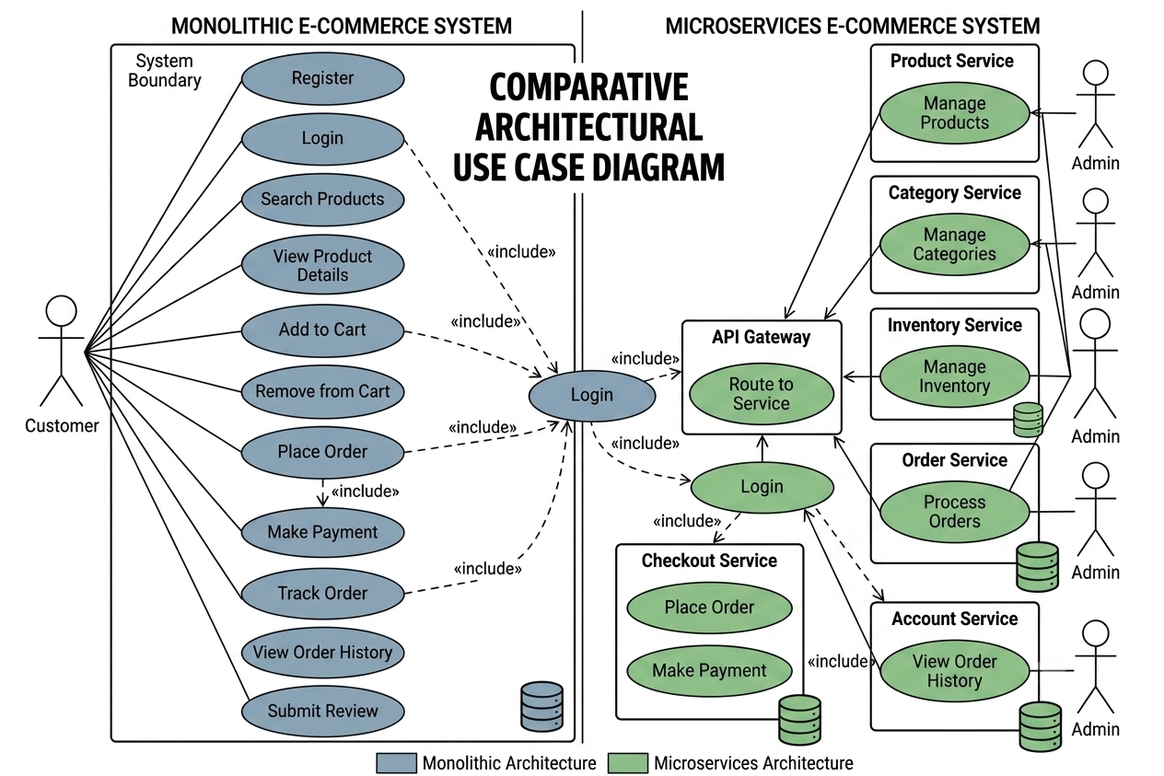
6. Implementation Strategy
Phase 1 – Requirement Analysis
- Gather customer requirements.
- Create Software Requirement Specification (SRS).
- Identify users

Phase 2 – System Design
- Design database schema.
- Design UI wireframes.
- Create UML diagrams.
- Develop system architecture.
Phase 3 – Development
- Implement user authentication.
- Develop product catalog.
- Create shopping cart.
- Integrate payment gateway.
- Build admin dashboard.
Phase 4 – Testing
Unit Testing
- Login
- Registration
- Product search
Integration Testing
- Cart + Payment
- Order + Inventory
System Testing
- Complete application testing
User Acceptance Testing (UAT)
- Verify business requirements.

Phase 5 – Deployment
- Docker Container
- AWS EC2
- MySQL Database
- Nginx Web Server

7. Evaluation Strategy
Evaluation Parameter | Method
Functional Accuracy | Requirement verification
Performance | Load testing
Security | Authentication and penetration testing
Reliability | Continuous monitoring
Usability | User feedback survey
Scalability | Concurrent user testing
Maintainability | Code review and documentation

8. Expected Outcomes
- Secure online shopping platform.
- Fast product search.
- Reliable order management.
- Accurate inventory updates.
- Secure online payments.
- Improved customer satisfaction.
- Scalable architecture for future enhancements.

